Snowflake Data Warehouse Creation and Power BI Integration
Practical Objective: To design, build, and integrate a complete cloud-to-dashboard analytics solution. This project is divided into two core phases:
- Snowflake Infrastructure & Data Engineering: Provisioning the necessary cloud compute architecture by configuring a virtual warehouse, creating a dedicated database and schema, and setting up file formats and stages to successfully ingest raw sample sales data into a structured table.
- Power BI Integration & Visual Analytics: Establishing a seamless data connection between Snowflake and Power BI Desktop to import, transform, and model the data. This culminates in the development of a professional, interactive dashboard utilizing KPI cards, date hierarchies, and diverse chart types to extract actionable business insights.

SNOWFLAKE:
- Configuration of Snowflake Virtual Warehouse:
Activate the COMPUTE_WH virtual warehouse to provision the necessary computational resources for executing subsequent SQL statements.

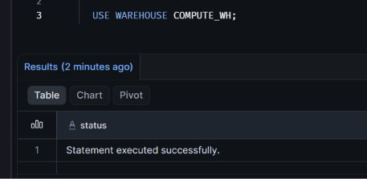

- Database Creation:
Create a new database named POWERBI_SALES_DB to isolate the project's data environment, and set it as the active database for the current session.

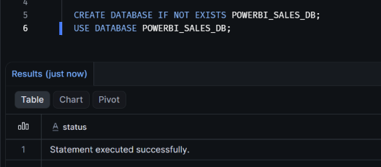

- Schema Creation:
Establish a schema named SALES_SCHEMA within the active database to logically organize the tables and stage objects.

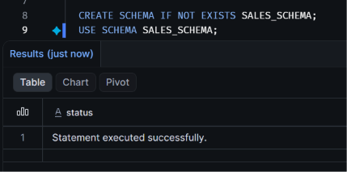

- Table Creation:
Define the SALES_DATA table with explicitly typed columns (ID, Customer Name, Product Name, Category, City, Order Date, Quantity, Unit Price, and Revenue) to hold the structured dataset

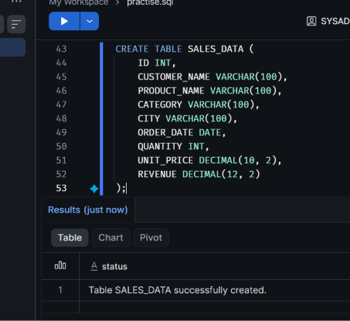

- File Format:
Create a file format named CSV_POWERBI_FORMAT configured to read comma-separated values and skip the initial header row during data ingestion.

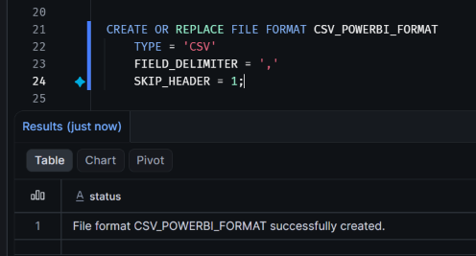

- Stage Creation:
Use the Snowflake Catalog Explorer web interface to manually upload the local sales_practical_datasets_3.csv file into the configured stage.

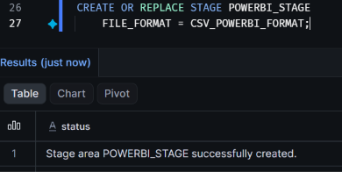

- Sales Data Upload:
Use the Snowflake Catalog Explorer web interface to manually upload the local sales_practical_datasets_3.csv file into the configured stage.

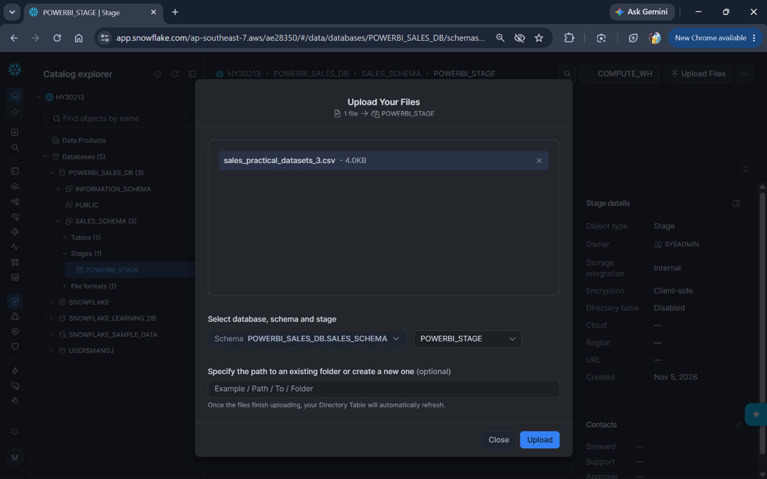

- Data is Loaded to Table:
Execute the COPY INTO SQL command to extract the data from the staged CSV file and load it permanently into the SALES_DATA table, successfully parsing the incoming rows.

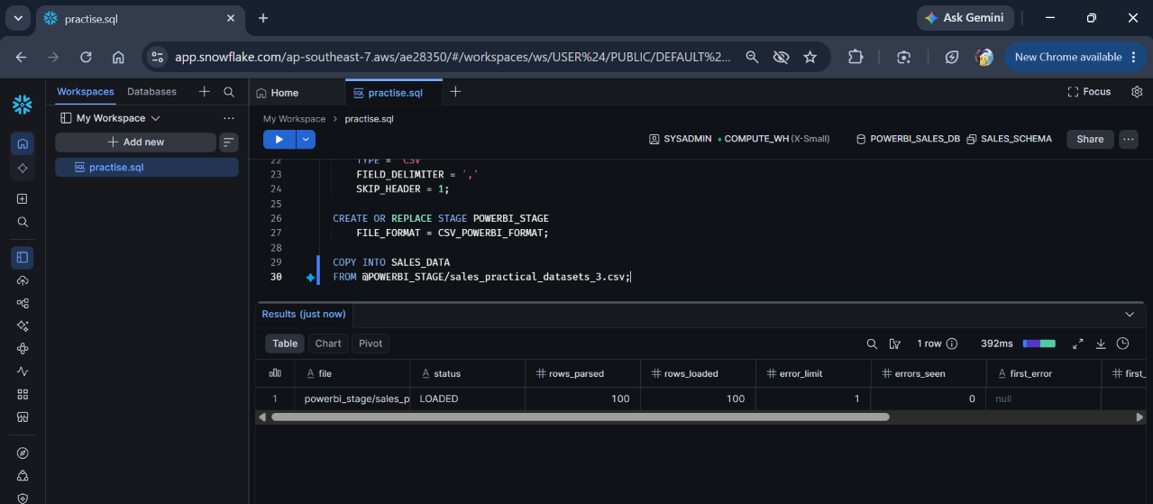

- Verification:
Run a SELECT * query against the SALES_DATA table to preview the dataset, ensuring all columns are properly populated and correctly formatted for downstream tools.

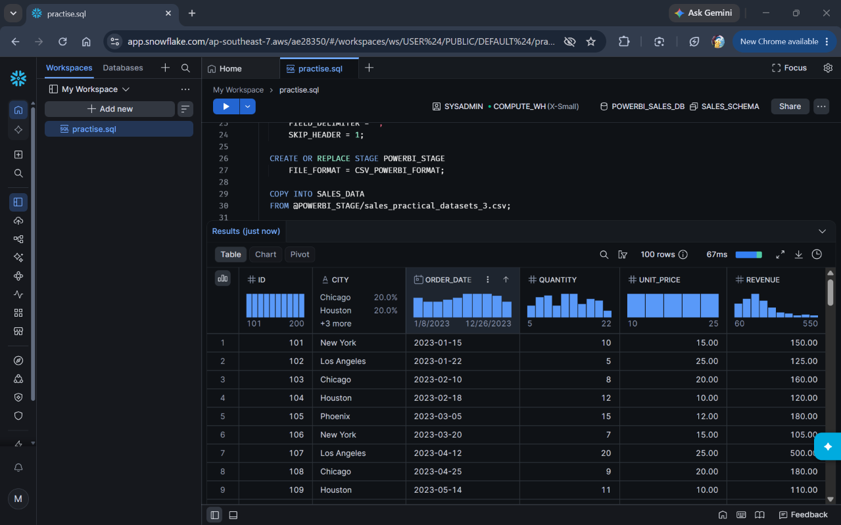

POWER BI:
- Snowflake Source Selection:
Open Power BI Desktop's "Get Data" menu and select the Snowflake database connector to establish a link to the cloud data warehouse.

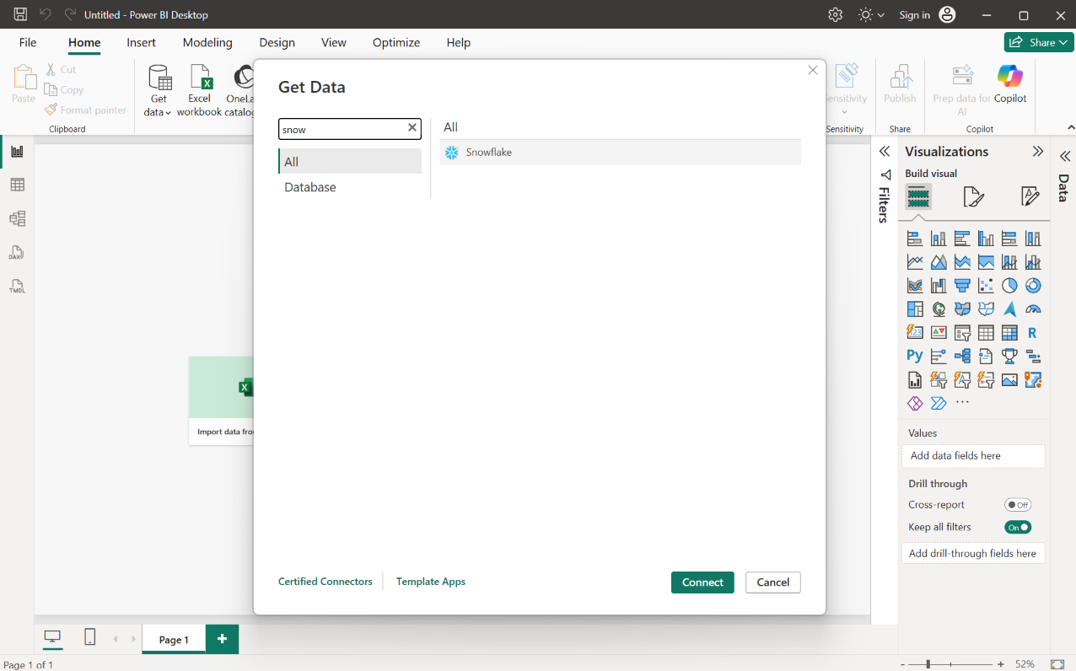

- Navigator:
Browse the Snowflake server hierarchy, locate the POWERBI_SALES_DB database, and select the SALES_DATA table for import.
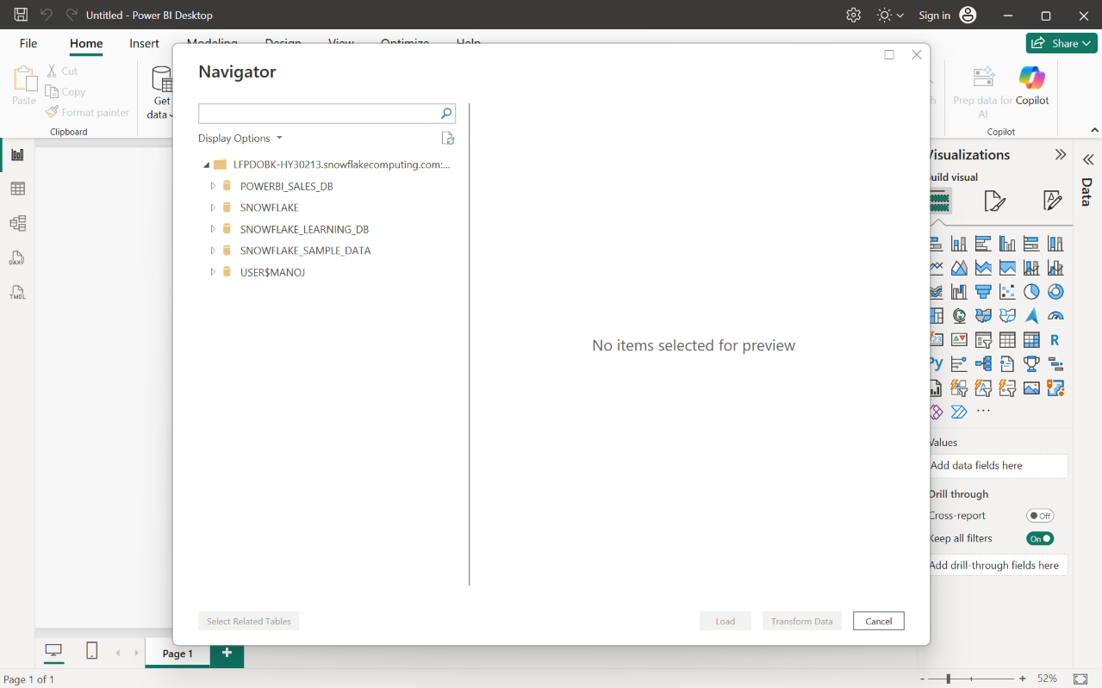
- Sales Data is Transformed and Loaded:
Verify that the imported SALES_DATA table appears in the Data pane with all fields properly recognized (including dates and numerical values) and ready for visual building.
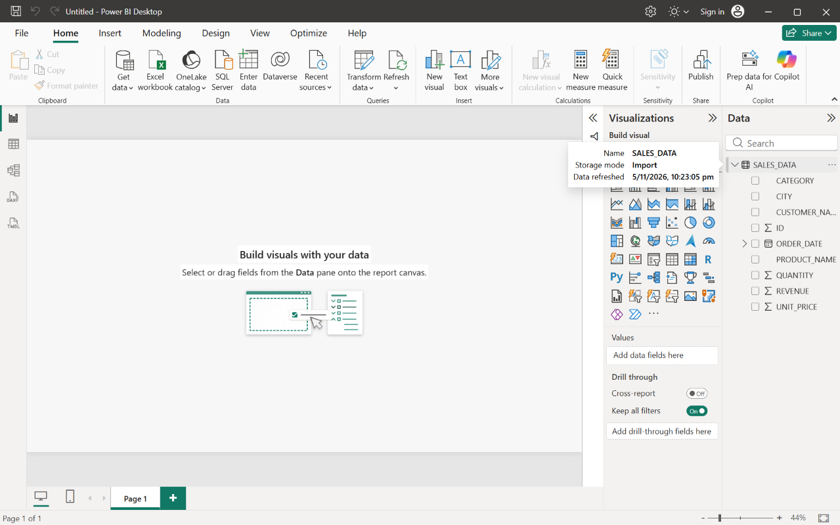

- Initial Cards
Create four KPI card visuals aligned horizontally at the top of the canvas to display primary aggregate metrics: Total Revenue, Total Customers, Total Orders, and Average Revenue.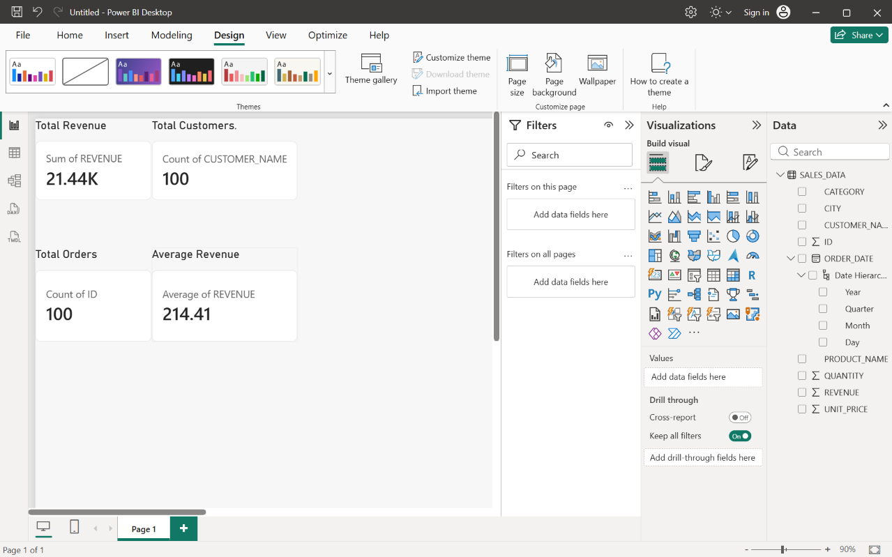

- Line Chart – Monthly Revenue Trend:
Plot ORDER_DATE (drilled down to the Month level) on the X-axis against the sum of REVENUE on the Y-axis to visualize revenue performance over time

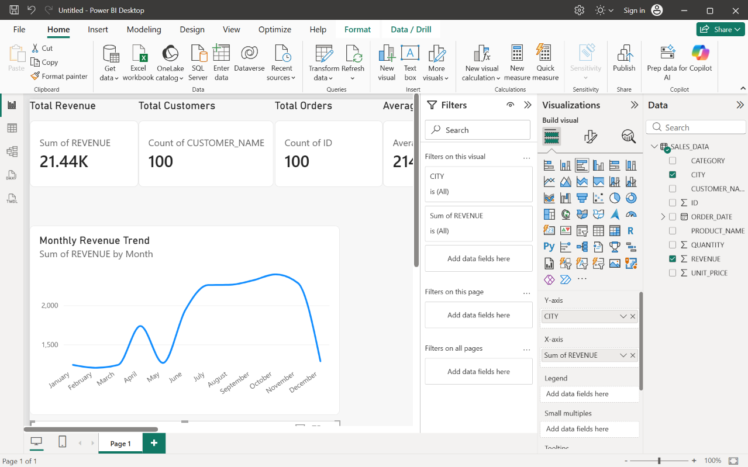

- Bar Chart – Total Revenue By City:
Configure a clustered bar chart with CITY on the Y-axis and the sum of REVENUE on the X-axis to compare total sales across different geographic locations.
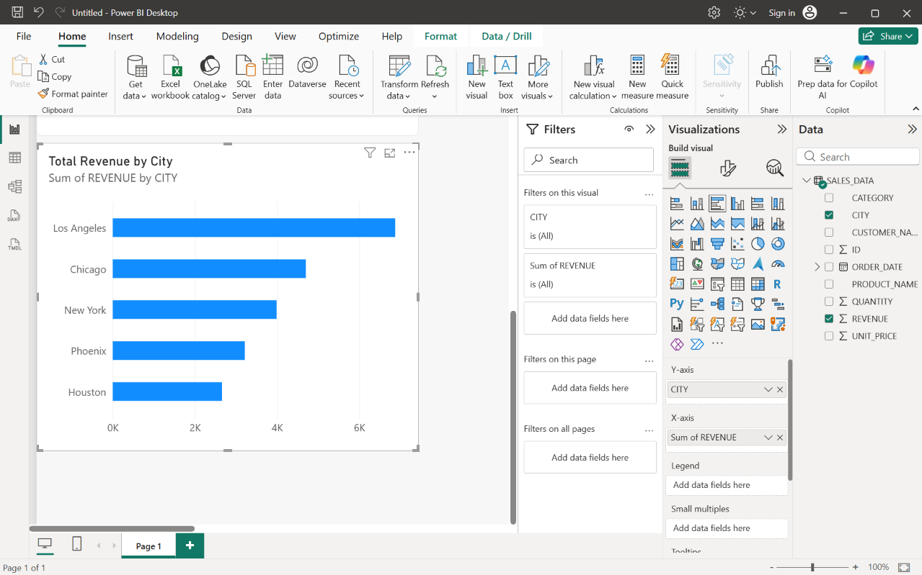

- Unit Quantity Sold by City:
Design a donut chart using CITY as the legend and the sum of QUANTITY as the values to illustrate the regional distribution of physical units sold.
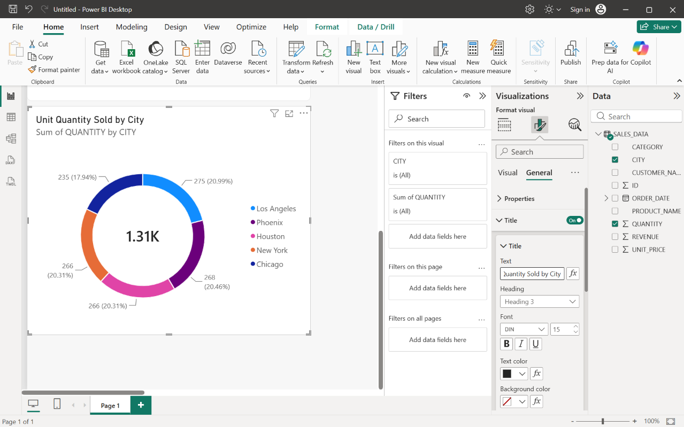

- Map Visual:
Plot CITY in the Location field and sum of REVENUE in the Bubble Size field to dynamically map revenue concentration geographically across regions.
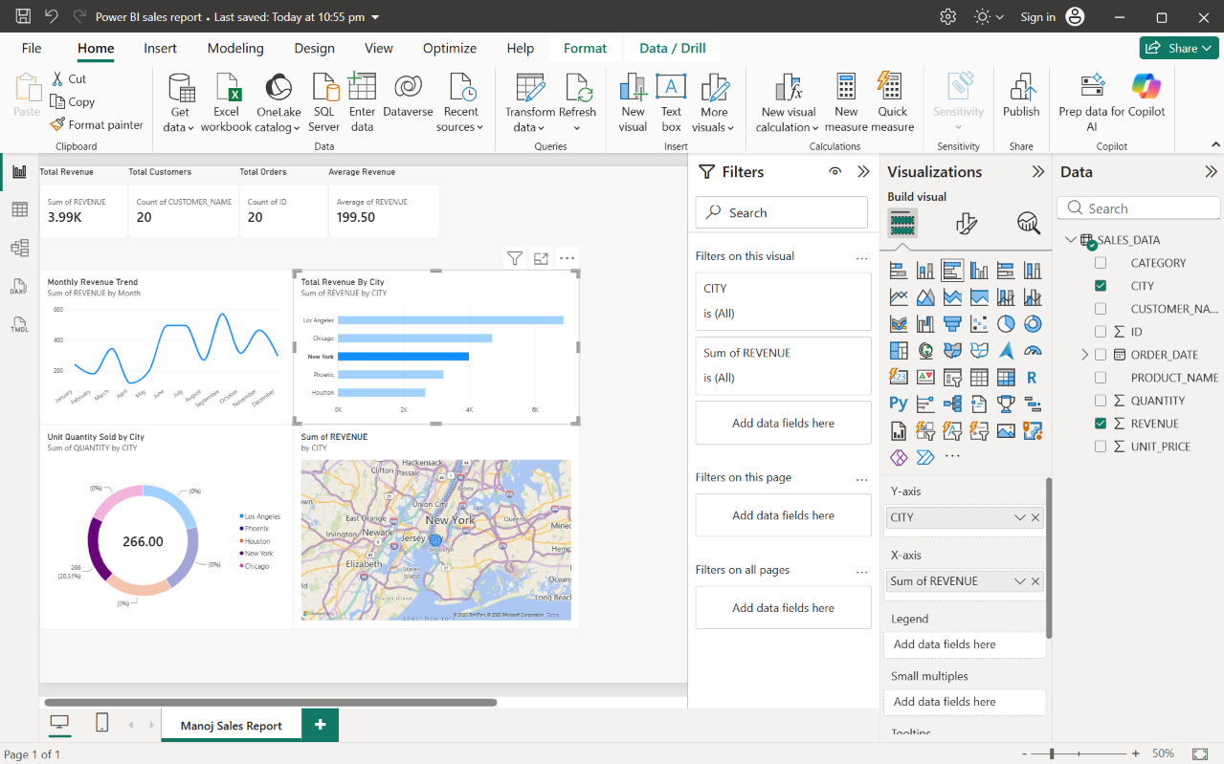
- Final Report:
Assemble all visual components—including the top KPI cards, line chart, bar chart, donut chart, map, and additional visuals like the funnel and matrix—into a strictly aligned, uniformly sized grid to produce a polished, professional dashboard



